# Prototype Description

We use android studio to create a system and we save the result {mind map , summarization ,word cloud } local in the device in any android devices ( tv , phone , tab ……. ) and use python to generate the mind map and make summarization and word cloud

Make a relation between android studio an muddle m5 in python let's get the result from our application

## Implementation Platform

Flask frame work

**Flask** is an API of **Python** that allows us to build up web-applications. It was developed by Armin Ronacher. **Flask's framework** is more explicit than Django's **framework** and is also easier to learn because it has less base code to implement a simple web-Application

Post man

Postman is a collaboration platform for API development. Postman's features simplify each step of building an API and streamline collaboration so you can create better APIs—faster.

Android studio by using java

You write Android apps in the Java programming language using an IDE called Android Studio. Based on JetBrains' IntelliJ IDEA software, Android Studio is an IDE designed specifically for Android development.

## Implementation Details

We are use many libariry for create mind map , word cloud and summarization :

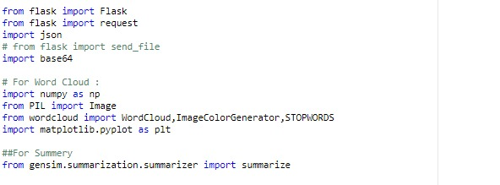

To implement summarization that sum up the text and make easier for user to read and under stand the text:

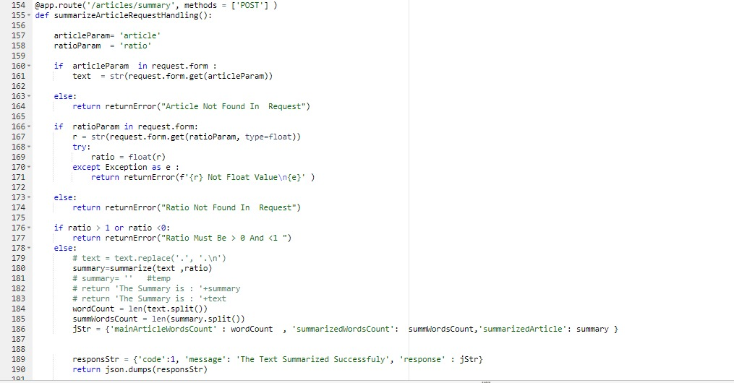

**to generate word cloud we use :**

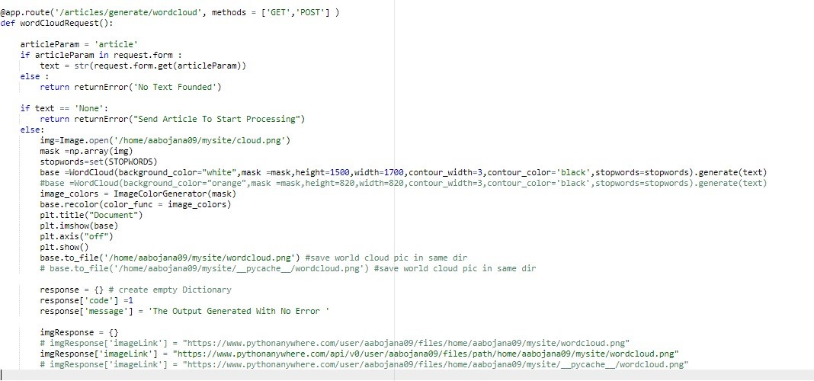

# 

# Testing

**Software Testing** is the process of identifying the accuracy and quality of the **software** product and service under **test**. ... At the end of the day, **testing** executes a framework or application with a specific end goal to point out bugs, errors or defects At the end of the day, testing executes a framework or application with a specific end goal to point out bugs, errors or defects. The responsibility of testing is to point out the issues of bugs and give Dev (Developers) a clue to help them fix it right following the requirements.

And we use Android Studio Profiling Tool to make tasting for our application and the result become :

